GPS Vehicle tracker
(GPS+GSM+SMS/GPRS)

User Manual

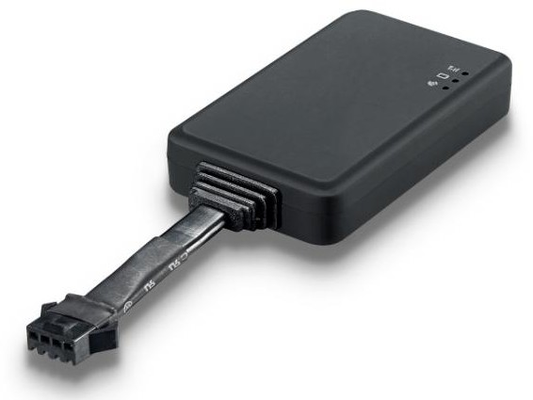

This user manual has been specially designed to guide you through the functions and features of your GPS vehicle tracker.

Standard accessories:
▶ Power cord

▶ Main Unit

Optional accessories:
▶ Relay

Specifications

Dimension | 65.5*38.5*13.5mm
Backup Battery | 120mAh / 3.7V
Voltage | 9-100VDC
Operation Temperature | -20℃-60℃
Humidity | 5% - 95%
GSM Frequencies | 850/900/1800/1900 MHz
GPRS | Class 12
GPS Channel | 20
GPS Sensitivity | -159dBm
Acquisition Sensitivity | -144dBm
Position Accuracy | 10m
TTFF （Open Sky） | Cold Start: ＜38s
TTFF （Open Sky） | Warm Start：＜15s
TTFF （Open Sky） | Hot Start：＜2s
GSM/GPS Antenna | Built-in design
LED Indicator | GSM-green, GPS-blue, Power-red
Data Transmit | TCP, SMS

- LED Indications

GPS LED Indicator - Blue
Flashing (interval 0.1s) | Searching GPS signal
Solid blue | GPS fix
OFF | No GPS fix or initializing

GSM LED Indicator - Green
Quick flashing (interval 0.1s) | GSM initializing
Slow flashing (flash 0.1s every 2s) | Receive GSM signal normally
Solid green | Connected to GSM network
OFF | No GSM signal

Power Status - Red
Flashing (interval 0.1s) | Low battery
Slow flashing (interval 0.2s) | Full charge
Slow flashing (flash 0.1s every 2s) | Normal operating
Solid Red | Charging
OFF | Low battery/Power off
Ignition detection indication: three LED indicators take turns flashing.

Getting Started
Please follow below instructions for ensuring safe and correct use.

Install the SIM card
Place the SIM card into the device with the blue-colored side facing down. Note: Make sure there is enough credit on the SIM card. If you will be using the
GPRS function, you should pay attention to the current SIM card GPRS charge.

Install the device
You need to choose somewhere that it won't be found, because the whole point of

fitting covert GPS vehicle tracker is the secrecy element.
Installation please refers to below picture.

NOTE:
- Any high power devices such as reversing radar, anti-theft device or communication equipment would affect the signal of the device.
- All metallic cases of the windshield will attenuate the signal on the tracking device. It’s simply due to the shielding effects of the metal compound of the case.
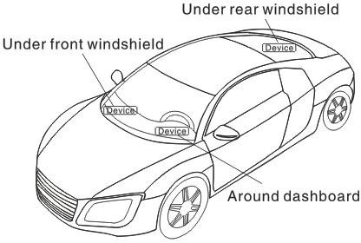

Wiring configuration

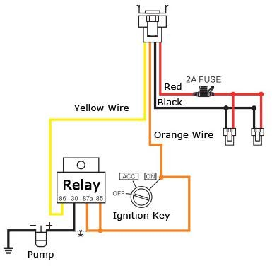

Line No. | Specification | Color | Instruction
 | MOTOR | Yellow | Connect to relay control line
 | ACC | Orange | Connect to ACC ignition
 | V- | Black(thick) | Negative side  car storage battery.
 | V+ | Red(thick) | Negative side  car storage battery.

Notes of the relay wiring
The relay wiring of pump: oil connectors of both ends are a fine white line (85) and a fine yellow line (86). The fine white line (85) is connected to vehicle positive power (+12V). The fine yellow line is connected to the device relay control line.
Cut off the positive connection line of the pump; then connect in series to the relay N.C. contact (thick green line 87a) and the other end to relay COM contact (thick green line 30).

Device wiring diagram

